**Workshop 2 Temporary Overvoltages (TOV) – Case of PV systems**

Date: 23/11/2023

Name: Javier muñoz sáez

**2.1 PV interface with controls**

Load the PV interface with controls example (Exa_25.acp) file.

Question 1: Describe the model: Emphasize how the solar panels are modelled, and how the inverter is driven. Also comment the several capacitances that are present in the model.

Suggestions:

* See the supplied reference by Cho et al. (2009).
* See the help available in each component of the model.

## Description of the model:

The ATP models a full 4800 solar panels installation, along with the DC/AC inverter connected to the grid.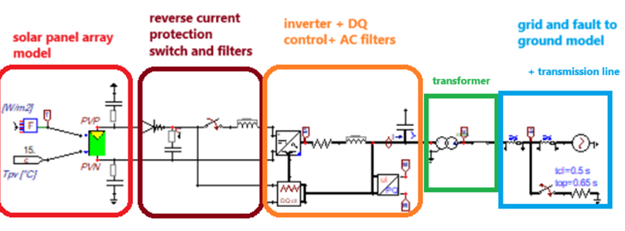

Modelling of the solar panels:

The PV array installation is modeled with the ATP block “PVarray”, this block calculates the IV curves from the provided data and takes into account Irradiation level and temperature as inputs.

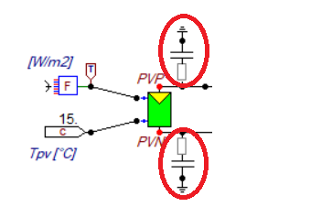

Both capacitor blocks located at both DC outputs are modelling the parasitic capacitance of the installation.

Right after the PV model, we find the reverse current protection diode leading right into the DC “buffer” capacitor.

After the capacitor there is a protection switch for the DC side, this switch will disconnect the PV array from the inverter in case of a fault.

There is also some inductive filtering (to correct the DC buffer reactance) , and a DC votlage measurement line that will be used by the inverter for its modulation.

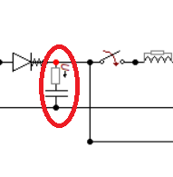

The inverter:

On the inverter side we find a fully controlled three-phase bridge, and a RL that could be modeling the three phase wires and the full bridge efficiency.

Similarly, like on the PV side, those capacitors model the parasitic capacitance of the AC side of the inverter.

Focusing on the modulation, this inverter is driven with park-clark transform blocks, this way the control could further reduce or compensate reactive power by juggling with Id and Iq currents.

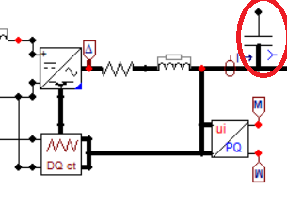

This inverter has the capability to control the provided reactive power as well as the active power to the grid.

## Transmission line , transformer and grid:

Right after the inverter we find a transformer, then the transmission line model and the grid model.

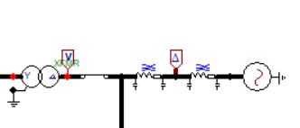

**2.2 Investigate TOV due to a single-phase fault**

Load the example file *Exa_25.acp*:



It is recommended to run it before any modification and check the measurements. Remove the 3-phase short circuit to ground on the grid side and add a *splitter* and a *switch time controlled*:



We will assume a constant radiation of 1000 W/m2. Edit the radiation reference (TACS Fortran) block:



Set the OUT=1000.

Set the single-fault short circuit to occur at T-cl = 0.7 s and to clear (open) at T-op = 0.8 s:



Question 2: Plot phase-voltages at the output of the transformer (grid side). Discuss the TOV during the fault (t=0.7 s to t=0.8 s) and after (t>0.8 s) the fault is cleared at t=0.8 s.

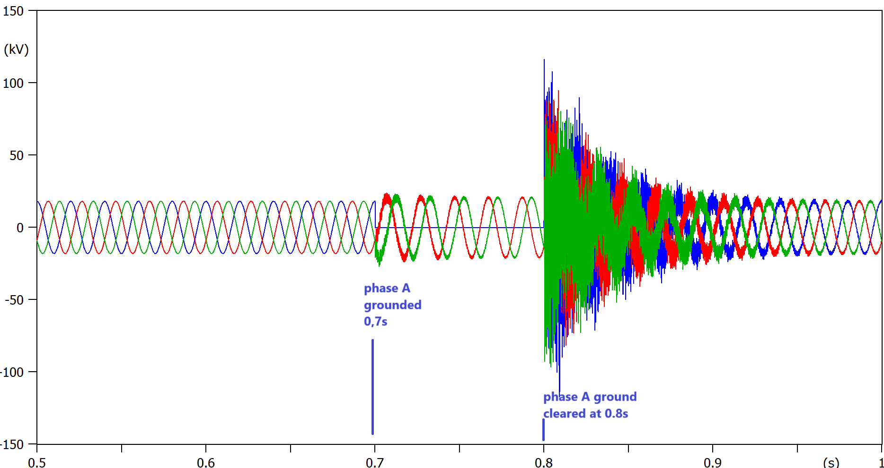

Figure , voltage at the transformer (grid side)

During the fault (between 0,7s and 0,8s), the two healthy phases B and C suffer an overvoltage ∼27% (ground is now phaseA).

The fuzzy noise that dissipates with time at the beginning and end of the fault is caused by the sudden fast TOV event (the faster the TOV the more harmonic content).

Right after the fault is cleared, (phaseA is not grounded anymore) there is another overvoltage ∼72%, this time much higher caused by the sudden released energy from the high current that was flowing trought the transmission line.

*tension transitoria de establecimiento, arco eléctrico* *cambio de medio, cambio de impedancia*

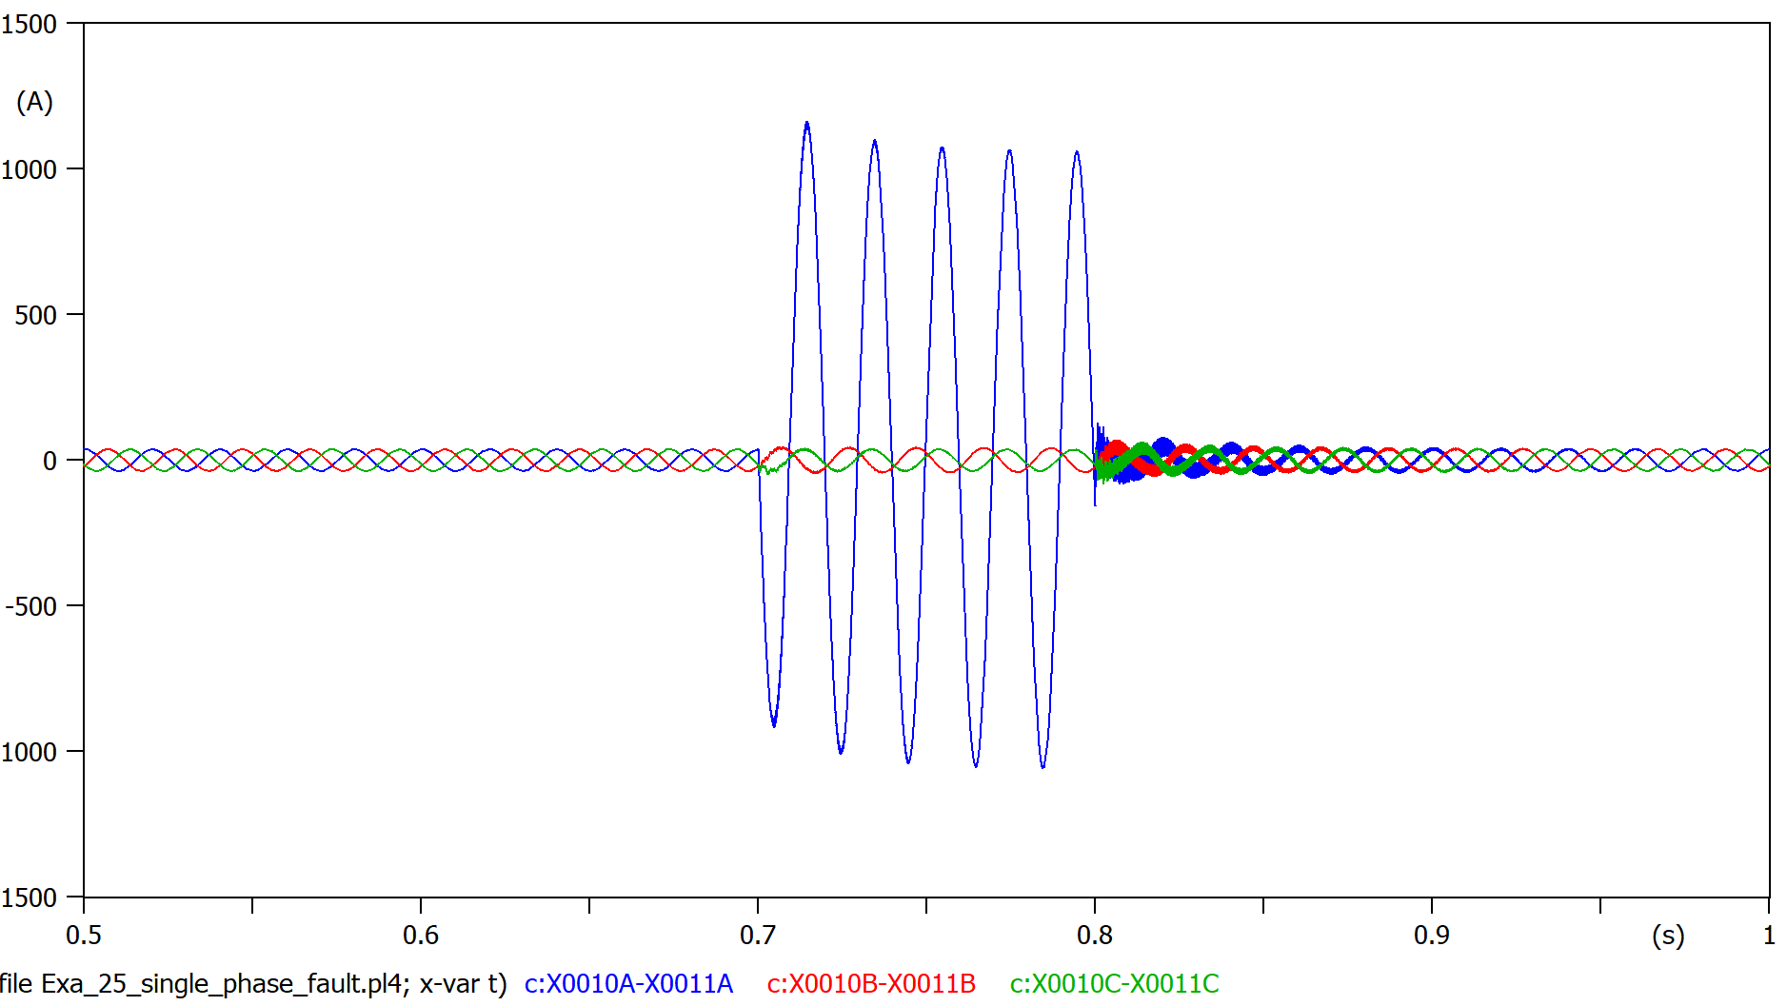

Figure current flowing into the transmission lines

**2.3 Investigate TOV due to load rejection**

**2.3.1 Load rejection**

Save the previous model with a new filename. Remove the single-phase fault and add a three-phase load (RLC3) between the two network segments.



Set the load (RLC3) as 10 Ohm and 0.001 mH for each phase:



Set the time of the load rejection (*switch time controlled, TSWITCH*) at t=0.25 s and the simulation time (Tmax) to 0.4 s:



Question 3: Plot phase-voltages at the output of the transformer (grid side). Discuss the TOV resulted from the disconnection of the load.

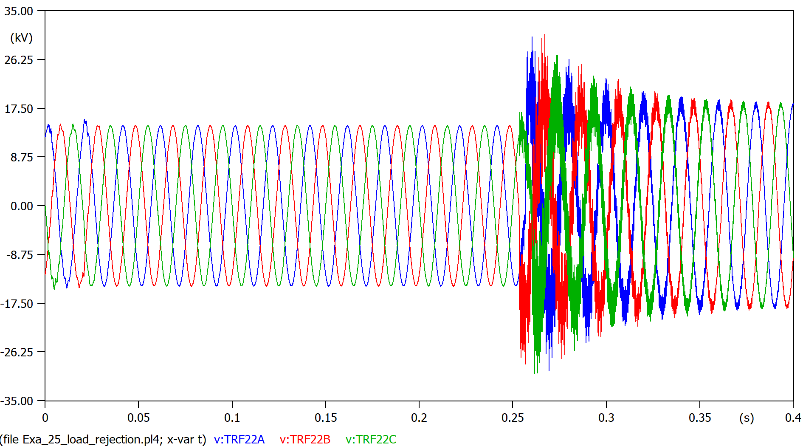

*tarda mas en reeestablecerse,viene del trandformacion*

**2.3.1 Islanding**

Now we will simulate the case of islanding of the PV generator.

Save the model with a new name. We will add a load (customer) at the output of the transformer. Just copy and paste the load that has been inserted in the previous simulation.



Set the two (*switch time controlled, TSWITCH*) of the loads to open later at 5 s (they will not open during our simulation):



Now set the switch after the transformer to open at t=0.2 s:



Now we have a PV generator that will be disconnected from the grid at t=0.2 s but still will have a load (customer).

Question 4: Plot phase-voltages at the output of the transformer (grid side).

Repeat the simulation for a customer resistance of 100 Ohm and finally 10000 Ohm:



Discuss what happen with the voltages supplied to the load (customer) for the cases of a load resistance of 10, 100 and 10000 Ohm.

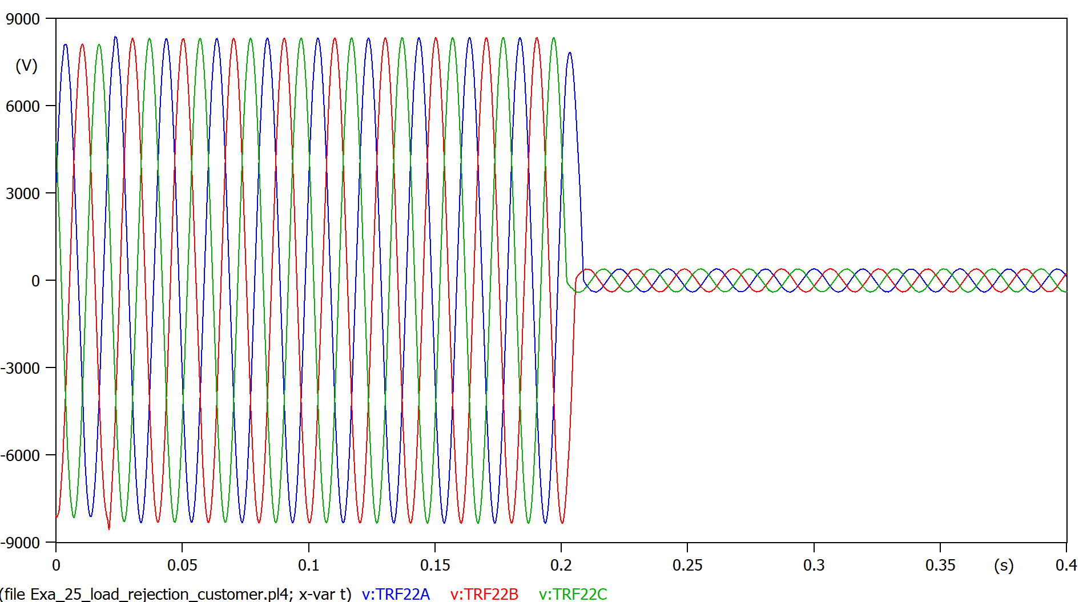

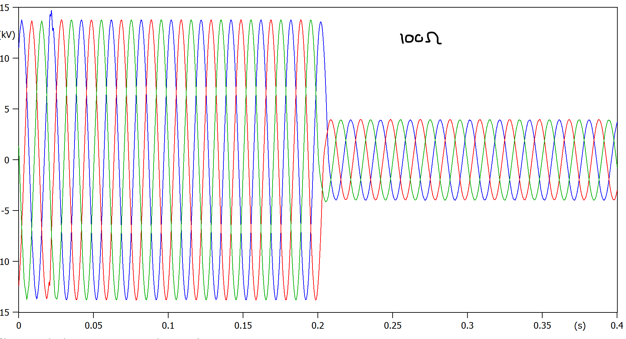

**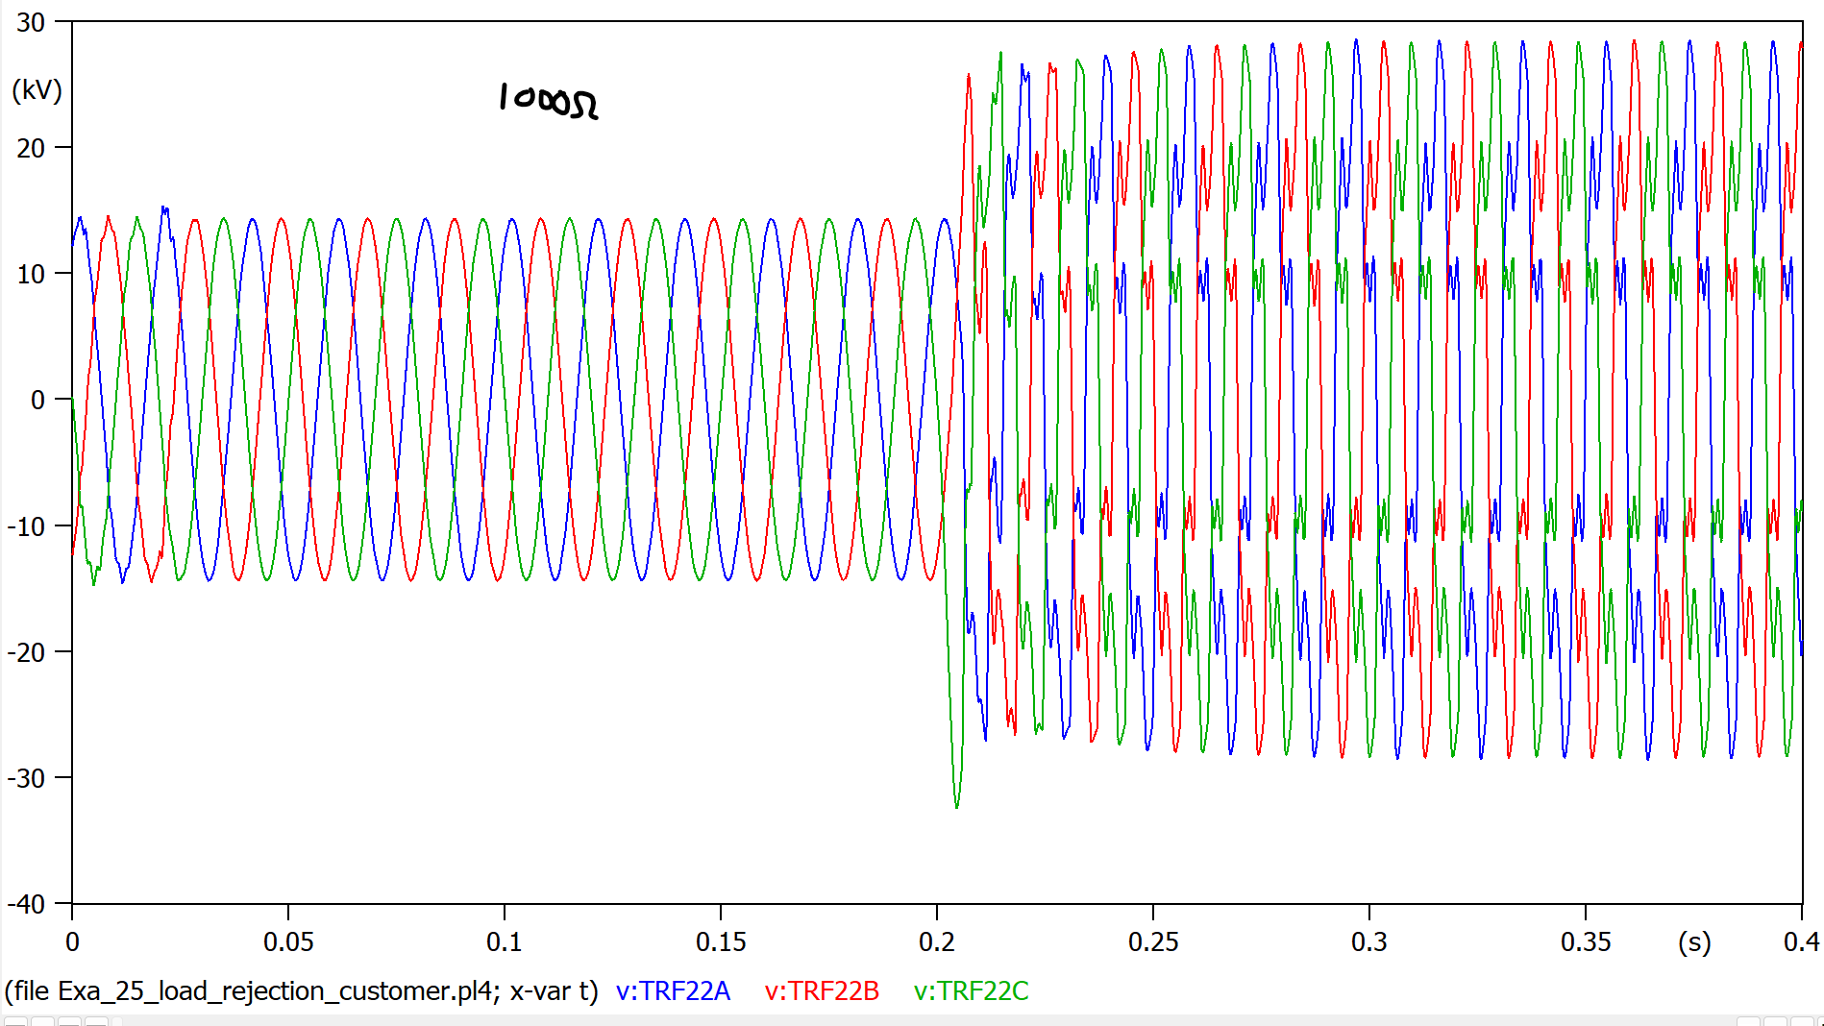  
*load rejection parecido.**